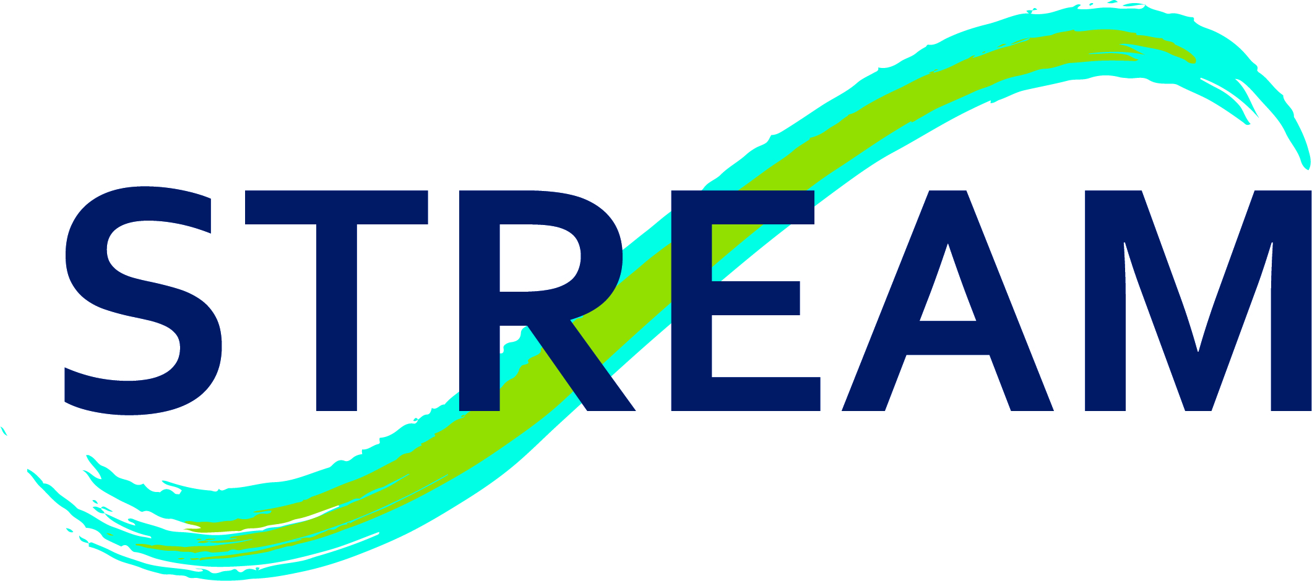
ONE PAGE EXPERTISE DESCRIPTION
Information about the expert
Organisation | STREAM
Address | Rue de Bruxelles 61, 5000 Namur
Type of partner | SME, University (spin-off: creation May 2021)
Website | http://stream-monitoring.com/

Contact person | Sofie de Volder
Email | Sofie.devolder@stream-monitoring.com
Telephone | +32474219705
Position | Business developer

Date of publication | 01/10/2020

Expertise Overview
Topic(s) of interest:
- Dye tracing and water network diagnostics (connectivity, leaking, residence time) with high spatial and temporal resolution in natural and industrial settings, using compact fluorometers.
- In-situ monitoring of water resources (turbidity, temperature, fluorescence).
- Hydrogeological and hydrological expertise.
- Deployment of a high amount of STREAM turbidimeters/fluorometers in a wide range of settings: surface water, groundwater, marine environment, water treatment plants, distribution networks, recharge areas, mine and quarry water discharge…

Headline:
STREAM can provide unique technology and expertise for a range of applications related to hydraulic connectivity, flow and groundwater characterization, vulnerability of water resources, water quality monitoring, and much more.

Potential contribution:
STREAM combines the development of an innovative technology with expertise in hydrogeology to provide targeted solutions to problems related to (ground, surface, distribution, waste) water flows.
The STREAM fluorometer/turbidimeter allows a direct, high-resolution measurement of fluorescence, turbidity, and water temperature. The small size and weight of the equipment enables a quick and easy installation in the field (natural sites, wells, pipelines, cave systems). STREAM fluorometers are autonomous and do not require an external datalogger or power source, which allows the equipment to be installed in almost any location.
STREAM’s strength lies in the ability to rapidly deploy a vast monitoring network. This network makes it possible to respond quickly and precisely to a large number of flow issues. We can provide a high amount of fluorometers and hydrogeological/hydrological expertise to any project.

https://link.springer.com/article/10.1007/s10040-017-1577-1#enumeration

